ECE 111 Final Project Report

1. **Explanation of SHA256 and Bitcoin Hashing**   
   *SHA256*: SHA stands for “Secure Hash Algorithm” and is a cryptographic algorithm that transforms input data of any kind and size (up to a certain maximum size) into a fixed-length hash value. SHA256 produces output hashes 256 bits long and can accommodate input message sizes of up to 264 bits. There are key properties of the SHA256 algorithm (and other SHA algorithms). Compression: all output hashes will be 256 bits long, Avalanche effect: a slight change in the input message should result in a drastically different output hash value, Determinism: the same input message must generate the same output hash value regardless of what machine it runs on, One-Way: it should be extremely difficult to get back the original message from the hash value, Collision resistance: it should be almost impossible to find two different messages with the same output hash value.

*Bitcoin Hashing*: Bitcoin is based entirely on the concept of digital blockchains, bitcoin itself is one giant blockchain. A blockchain consists of multiple blocks, and each block contains transaction information of bitcoin between individuals. In addition to containing transaction history, each block is chained to the previous block that contains the information of the previous transaction with hashes. Every time a transaction is made, the new block will add the identifying hash of the previous block before computing its own identifying hash. These hashes are computed using algorithms like SHA256. If someone changes the data in a block maliciously, that block’s own hash changes and (should) no longer match the hash the next block stores of it. If a collision were to occur (2 different block transaction messages map to the same hash), the blockchain would be compromised since someone could change the original transaction information without breaking the blockchain and alerting everyone of the break. Not all hashes are allowed for a block, sometimes they must begin wth a certain number of a certain character, and usually, a bit of modifiable information is added to the end of every block and modified until the output hash matches what you desire.

1. **SHA256 and Bitcoin Hashing Implementation**

*SHA256:* The SHA256 algorithm we implemented consists of multiple stages. In order to implement these multiple stages, we use state machine logic with multiple states. First, in the initial IDLE stage, we load in the required constants for initial hash values in h0-h7 that are necessary later on. Then we move to the READ stage, where we read the input message from memory and record its length. We then move to the BLOCK state where we pad the message. We add a single 1 to the end of the message and then pad the message with 0s until the length of the message is 64 bits less than some multiple of 512 bits. Then, the remaining 64 bits are used to record the length of the original message. After this, we move to the COMPUTE stage and start the SHA256 algorithm. We process the message in blocks of 512 words. We use those constants we initialized and store them in some temporary variables (a, b, c, d, e, f, g, h). Then we perform the 64 rounds of word compression updating (a, b, c, d, e, f, g, h) every time. At the end of the compressions, we add a-h to the initial hash constant h0-h7, and this is the output hash of the first block and serves as the initial hash of the second 512-bit message block. These rounds of compression continue until all message blocks are processes, and we have our final value stored in h0-h7. We finally move to the WRITE stage and write these hash values to memory. We optimized this module for area by not generating an array of 64 elements when doing the word expansion stage of the project. Instead, when generating each new word past the 15th iteration, we generated the word and stored it in the 16h element of the already existing 16 element array. This saves a lot of area.

*Bitcoin Hashing:* The bitcoin section of our project involves using a modified version of the SHA256 module and algorithm we did in the first part to compute the hash values of the message after varying the last word in the message (the nonce) to take values between 0 and 15 (16 different nonce values). We modified the SHA256 module such that we pass in 16 words (512 bits) and initial hash constants for the SHA256 algorithm to produce an output hash out of after 64 rounds of compression. The bitcoin part consists of a multi-stage finite state machine as well. In the first phase, the initial hash constants (the same for every type of nonce) along with the first 16 words of the message are passed into the modified SHA256 module and an output hash is computed. This output hash will serve as the initial hash constant for the second message block (3 remaining words of message + nonce + padding). In the second phase, we instantiate 16 SHA256 modules (one per nonce value) and load in the next 3 words of the message, plus one more word which is the nonce value (each module has a different nonce value), but load in the same initial hash constants. An output hash is computed for each nonce value and then we move to phase 3. Phase three uses the output hash of the second phase as the input message for the respective SHA256 modules with their specific nonce values (padding is added to this message). The initial hash constants that are passed in are the same as the very first initial hash constants. After this phase, the output hashes for each nonce value computed are the final hash values, and then we move to the write phase where they are written into memory (first hash word per nonce). This is a very simplified version because we aren’t trying to reach a specific target hash like it is usually done. This version of bitcoin hashing that we implemented is the most optimal version because we compute each of the hashes for phase 2 and 3 separately and parallely per nonce value. And we only need to compute the hashes for the initial phase once because the output hashes of that phase are the inputs for each nonce value of the next phase, regardless of the nonce value.

1. **Simulation Waveforms**

*SHA256:*

General Overview:

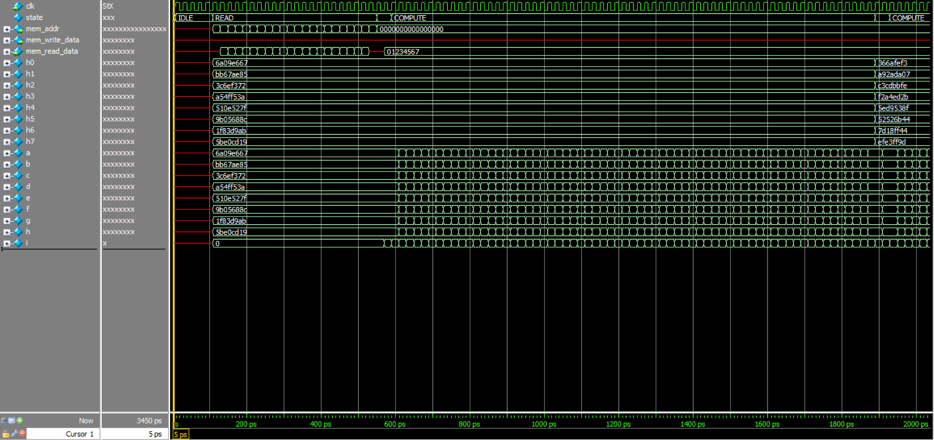

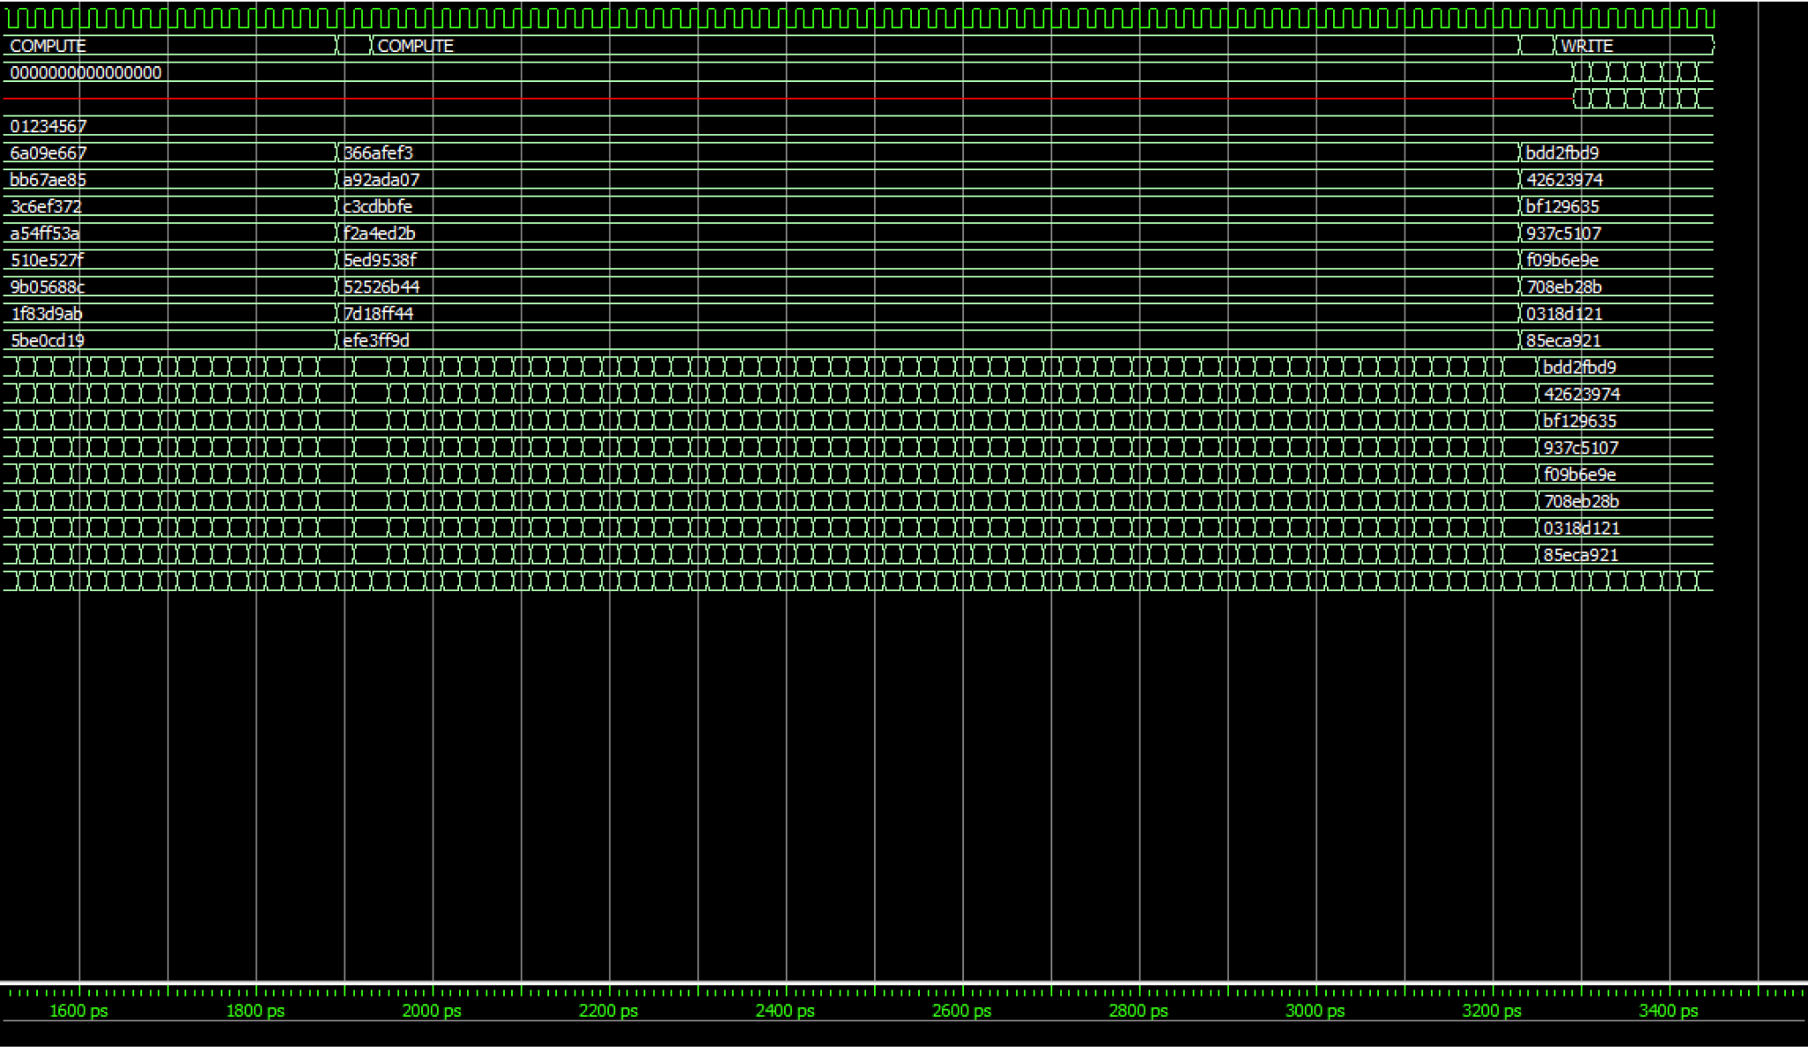

Detailed View of a-h, h0-h7:

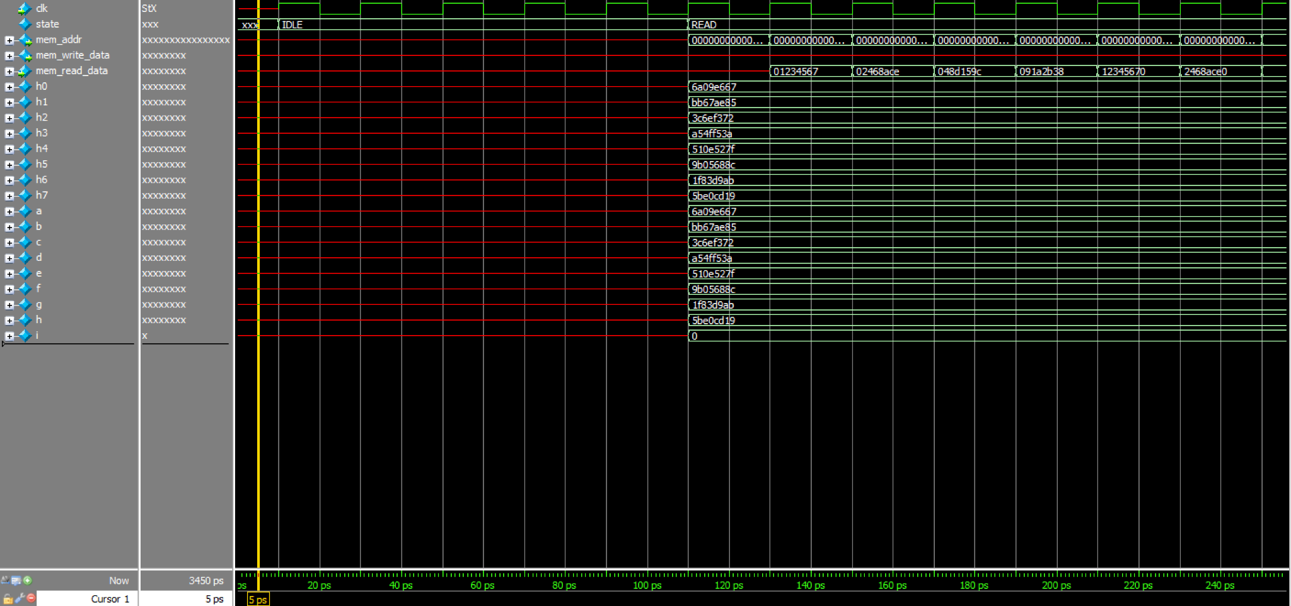

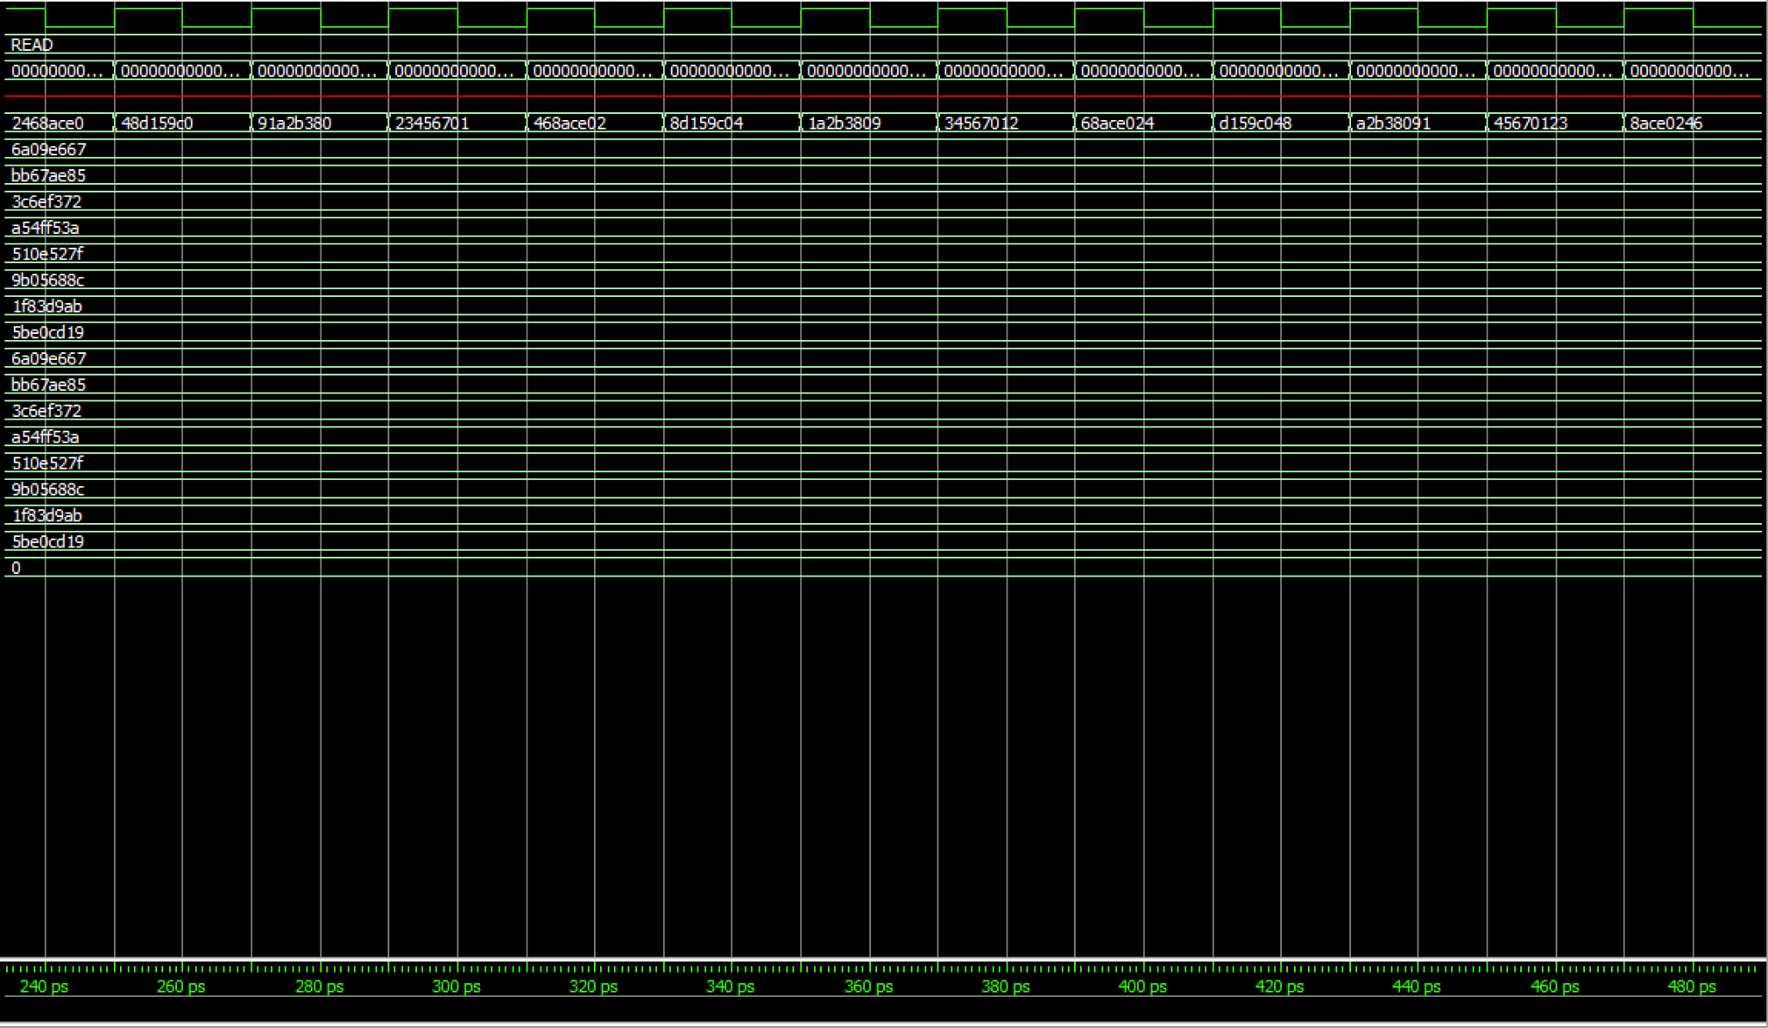

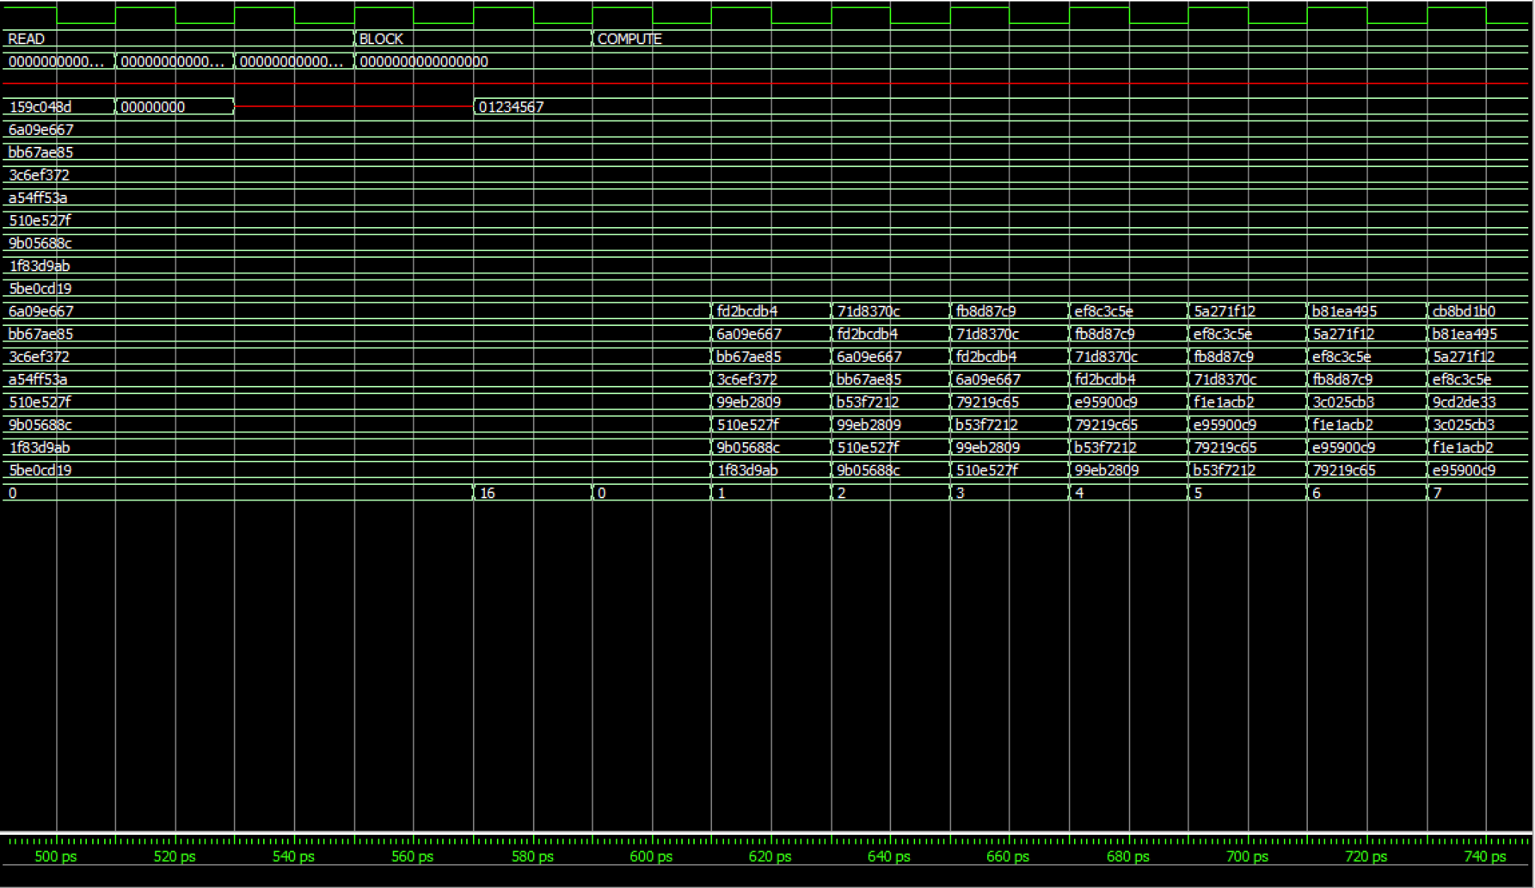

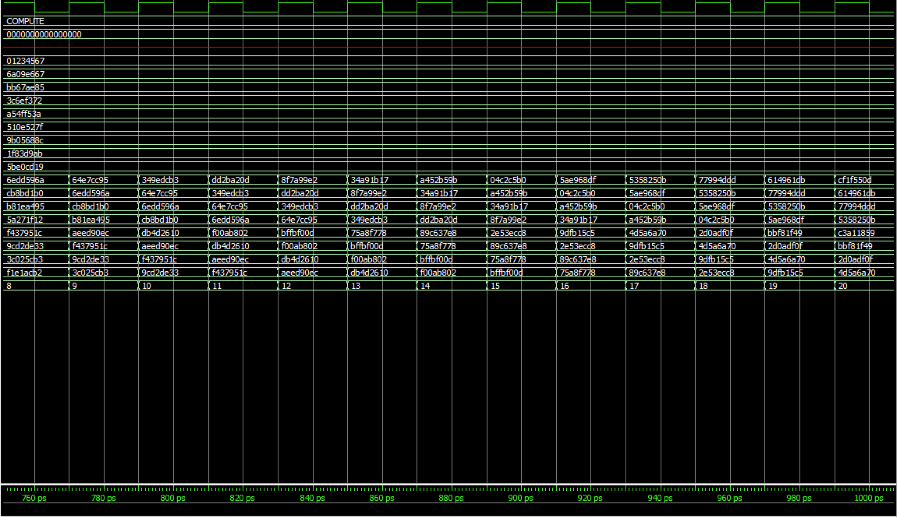

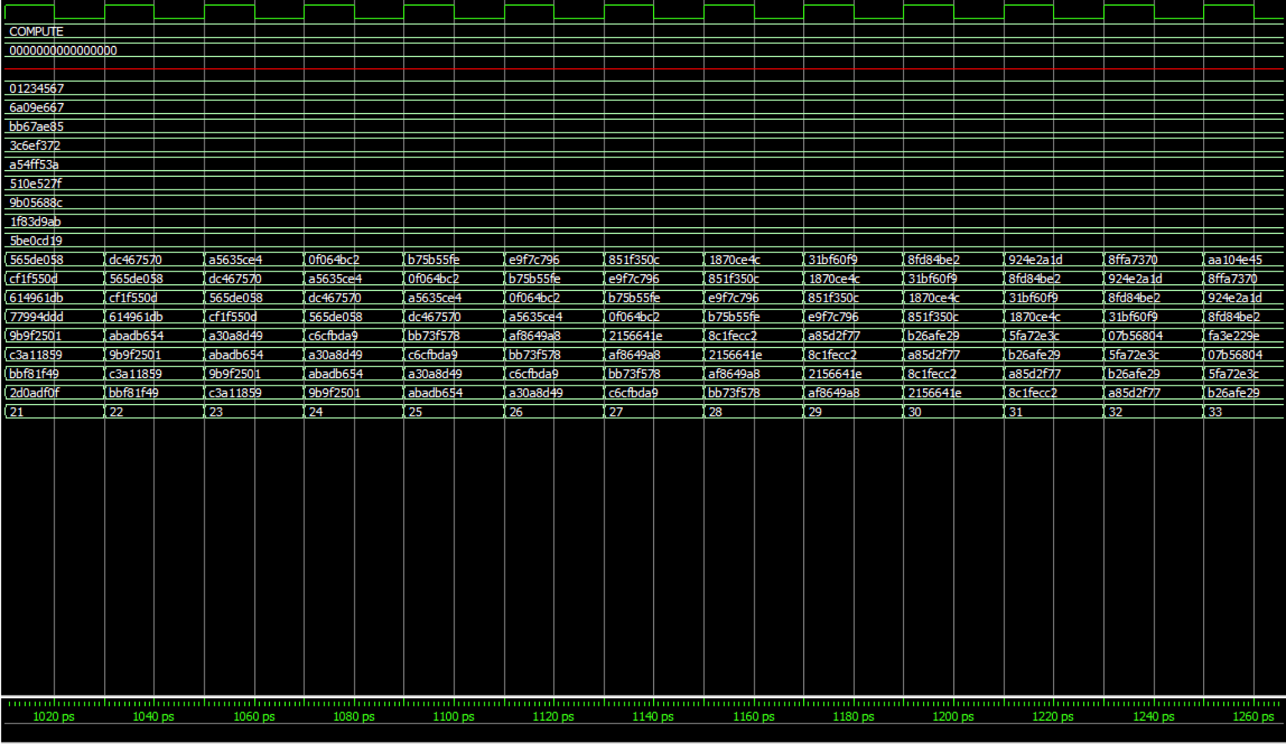

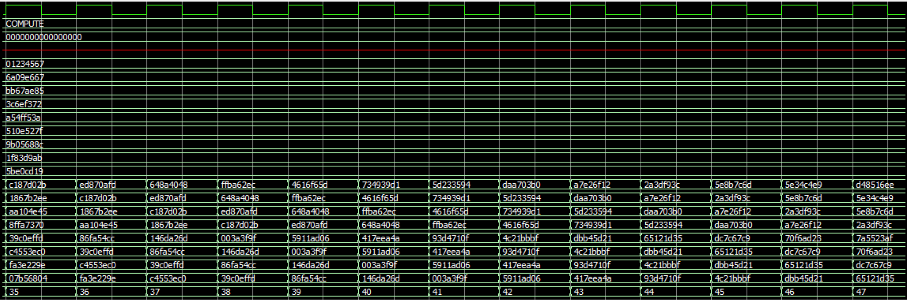

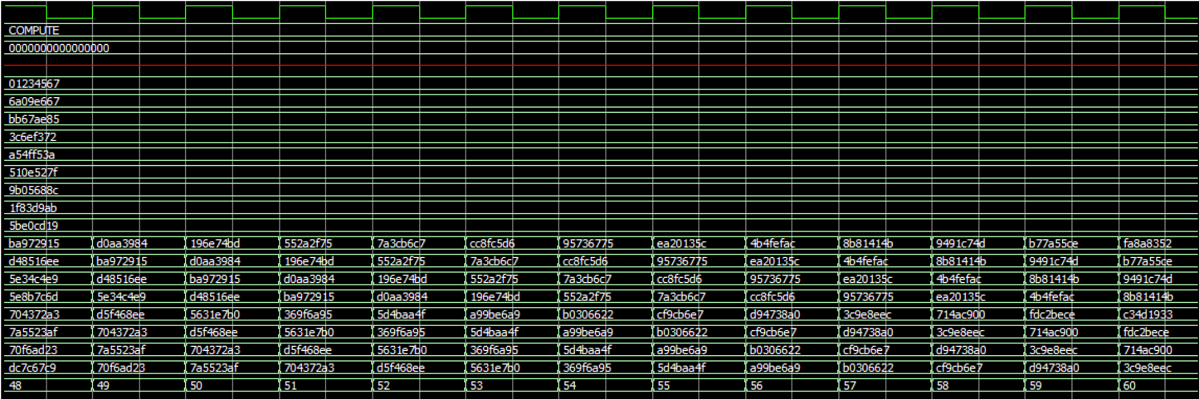

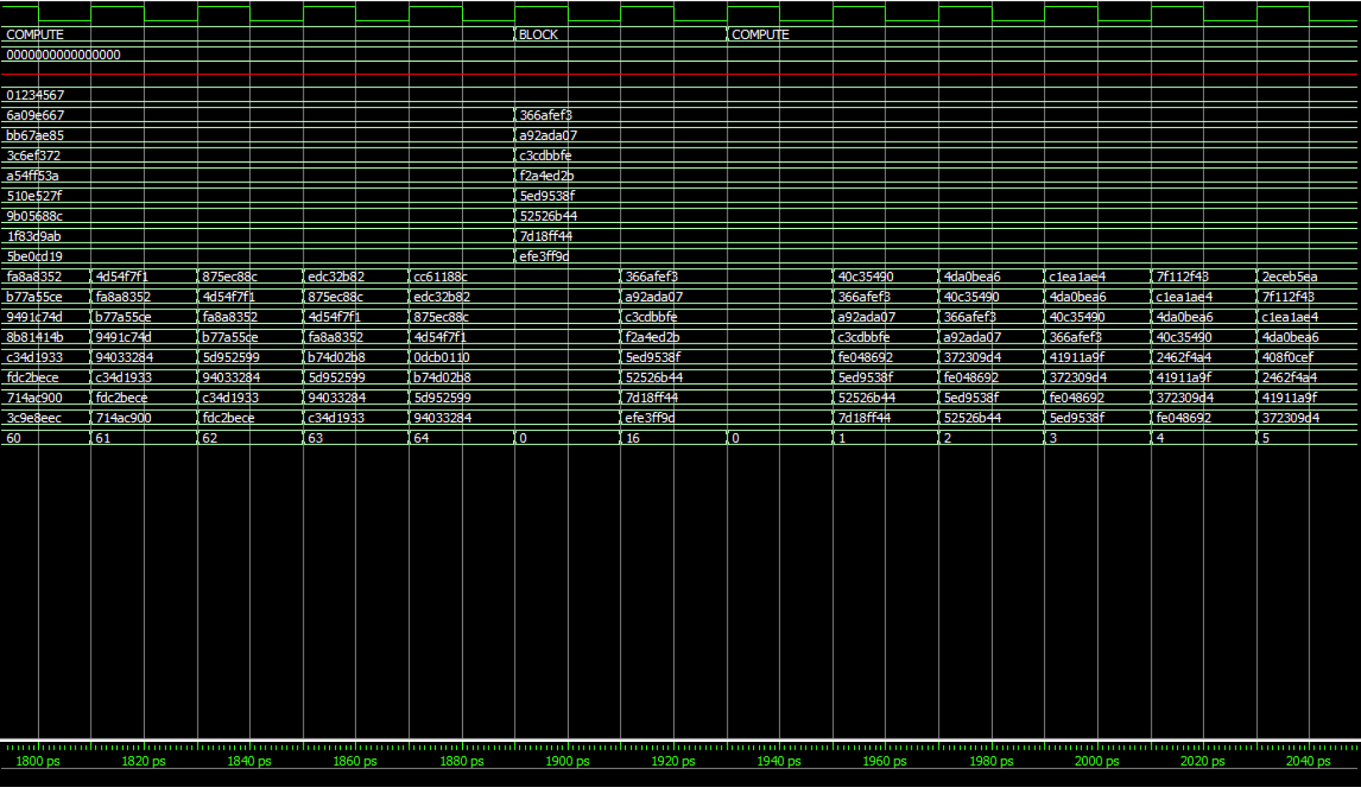

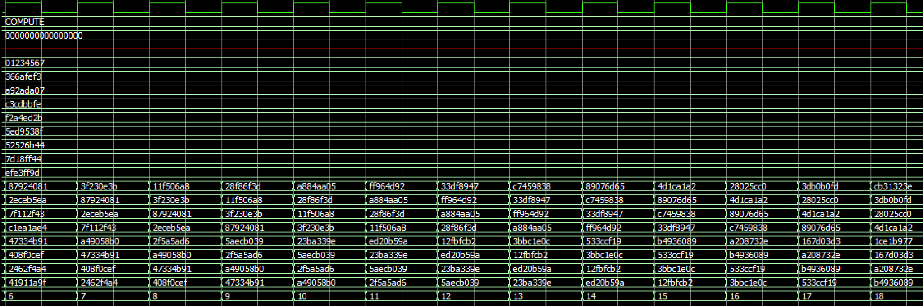

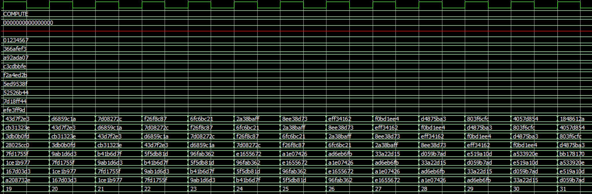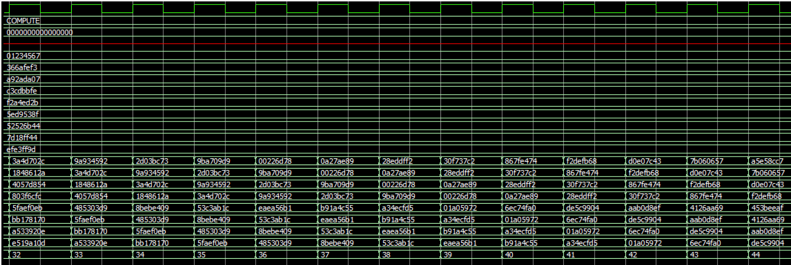

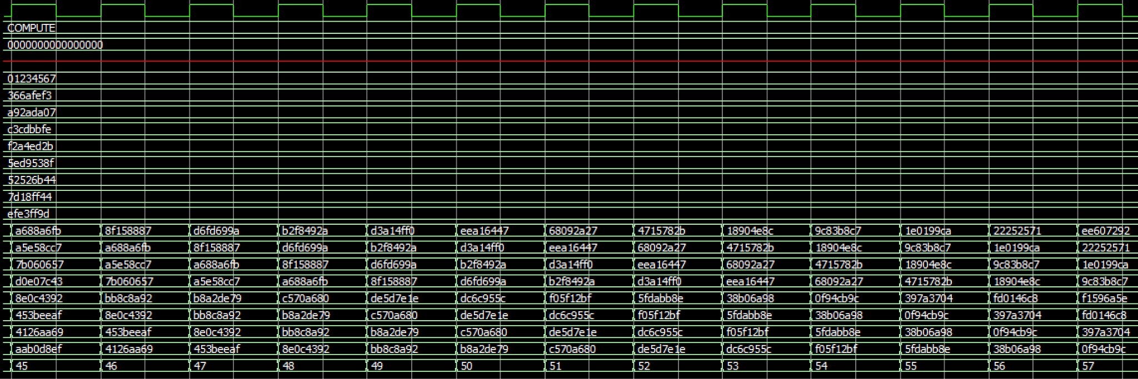

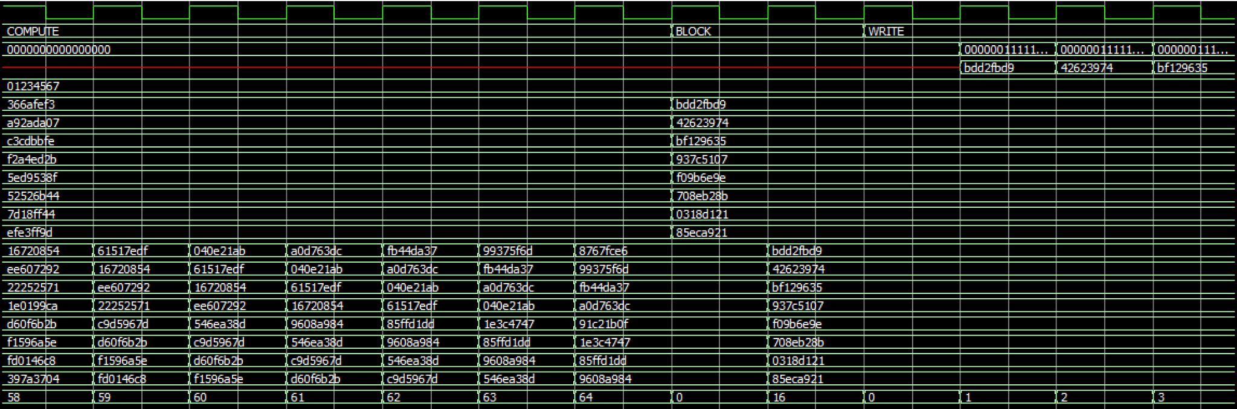

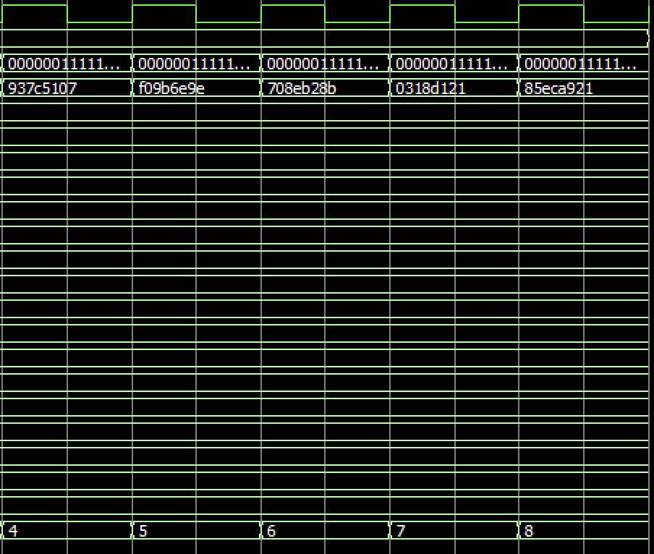

If you track all the values of a, b, c, d, e, f, g, h then you will find that they exactly match the values from the spreadsheet with the correct a, b, c, d, e, f, g values at every stage. We can see the same for the values of h0 - h7 as well. We can see that the hash value of the first message block is computed when h0-h7 changes and then the next message block hash values start to compute. Then we see the hash values h0-h7 change one more time, and this is the final hash value, which is correct.

*Bitcoin Hashing:*

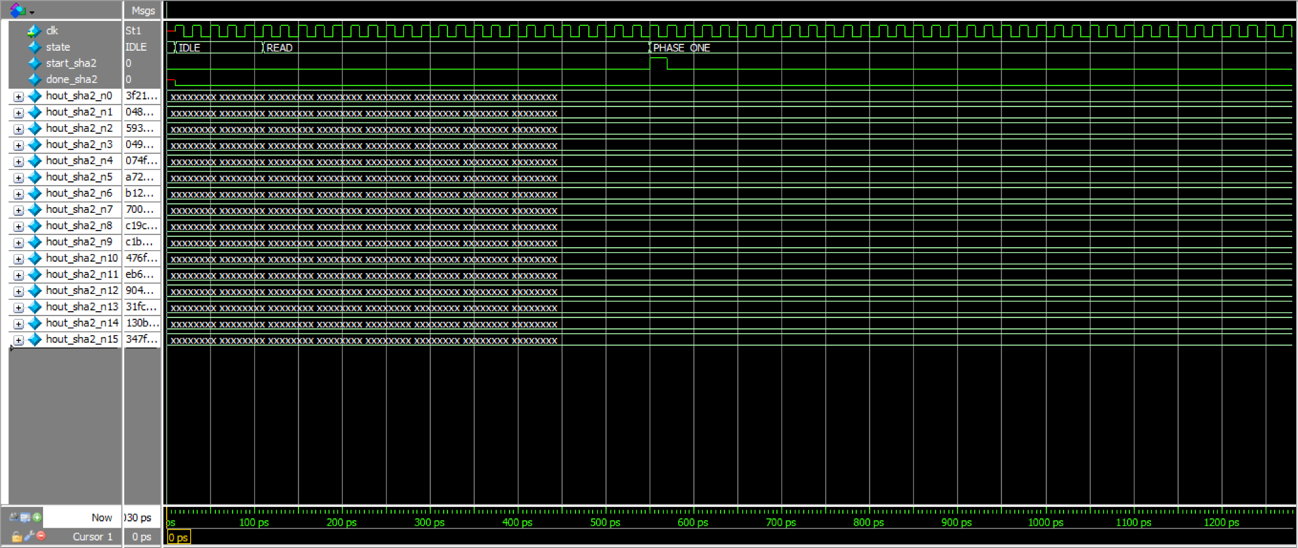

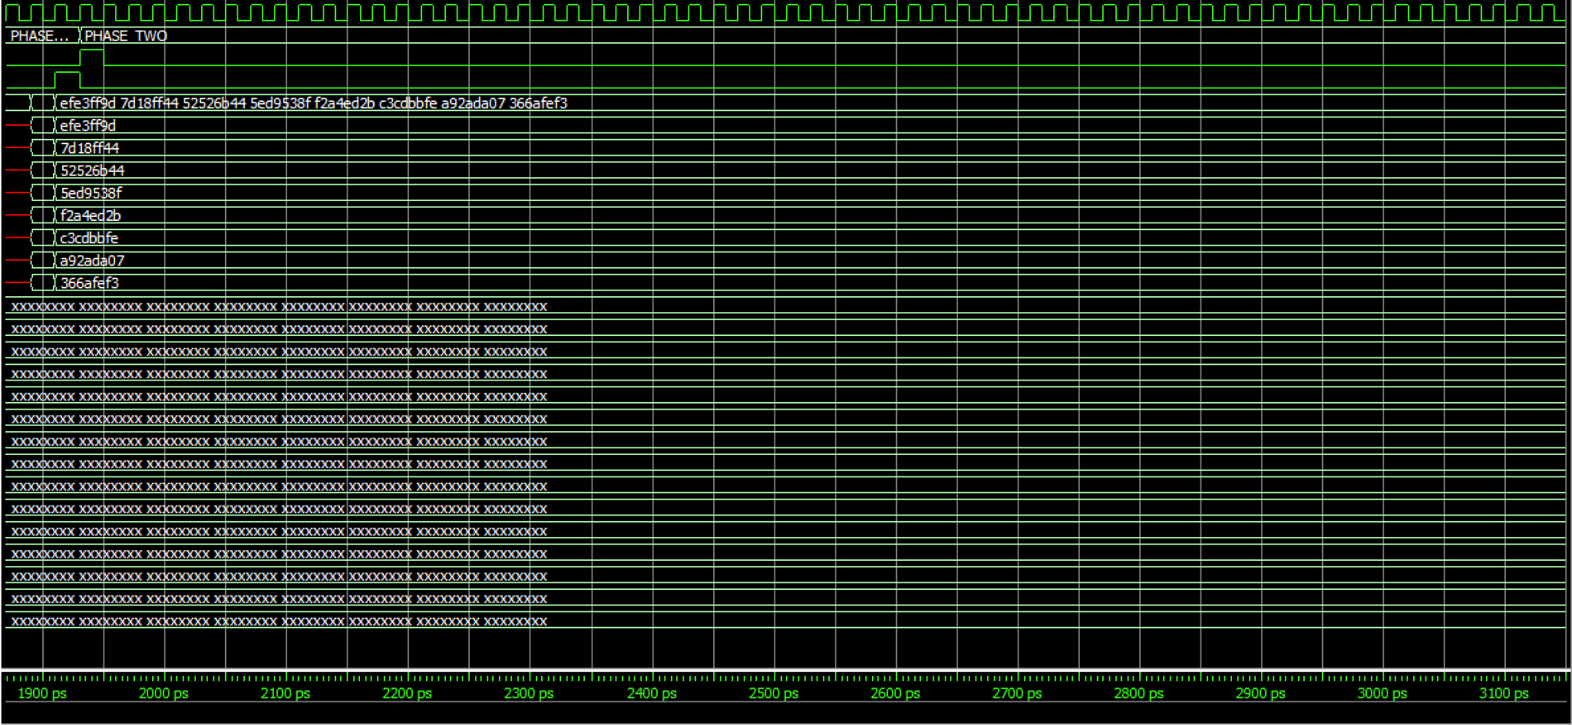

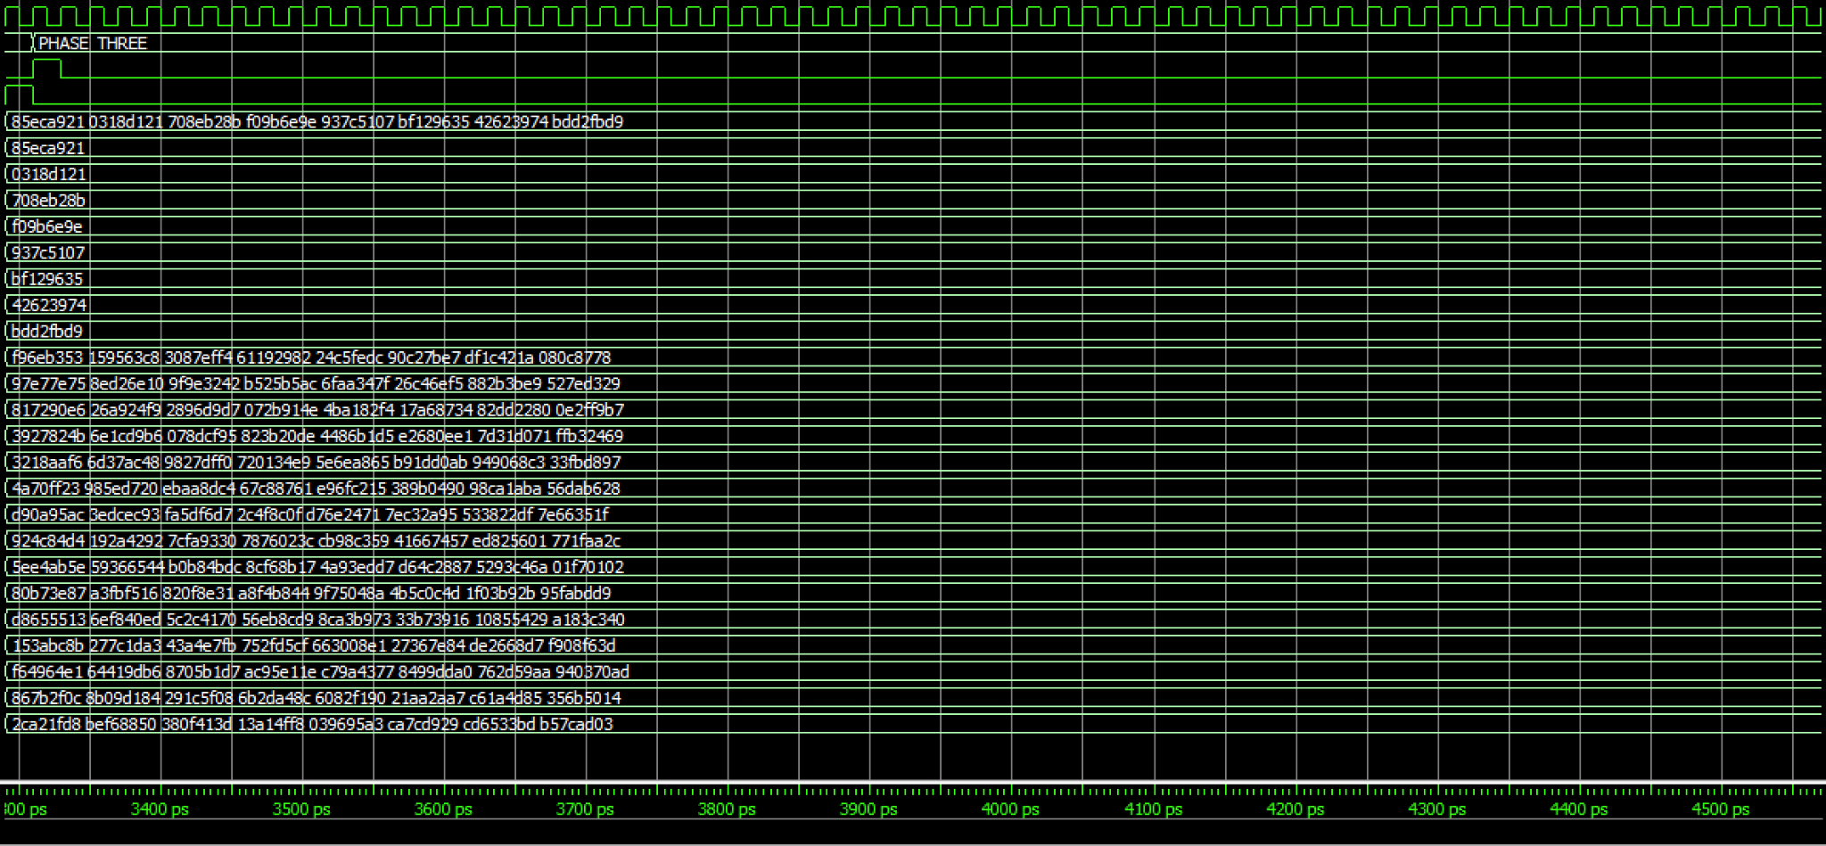

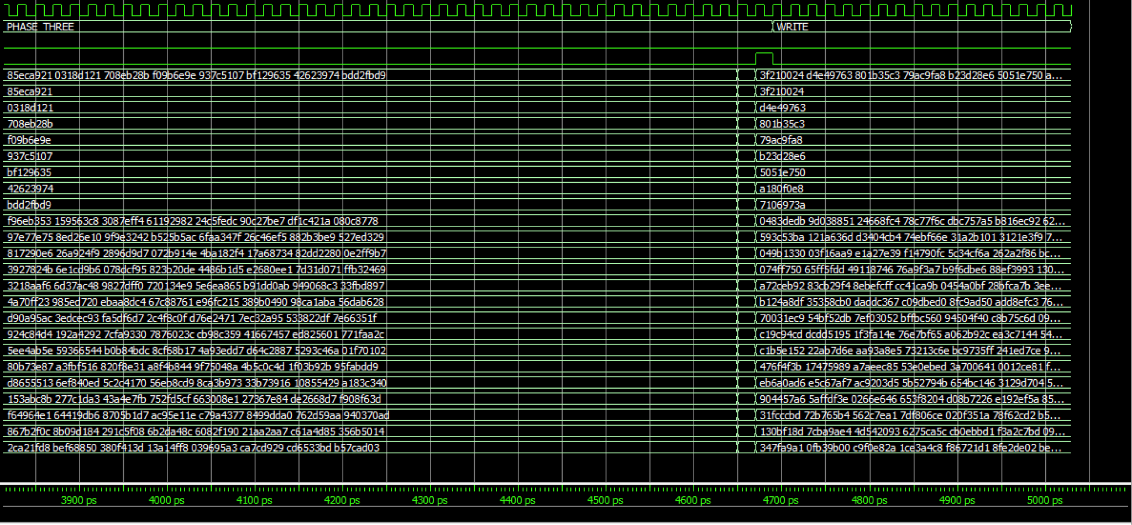

*If you follow all the output hashes, you can see that each one of them is correctly computed at the end of each phase, and perfectly matches up with what is on the Excel sheet of correct hash values.*

1. **ModelSim Passing Transcript**

*SHA256:*

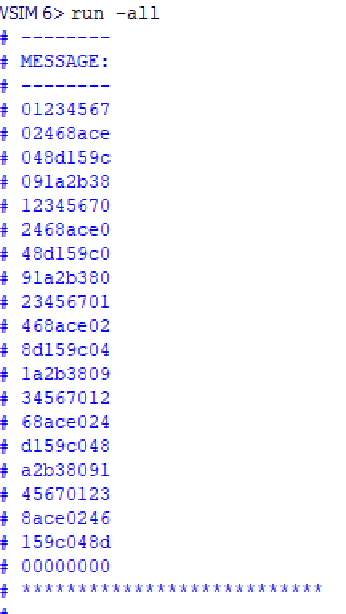

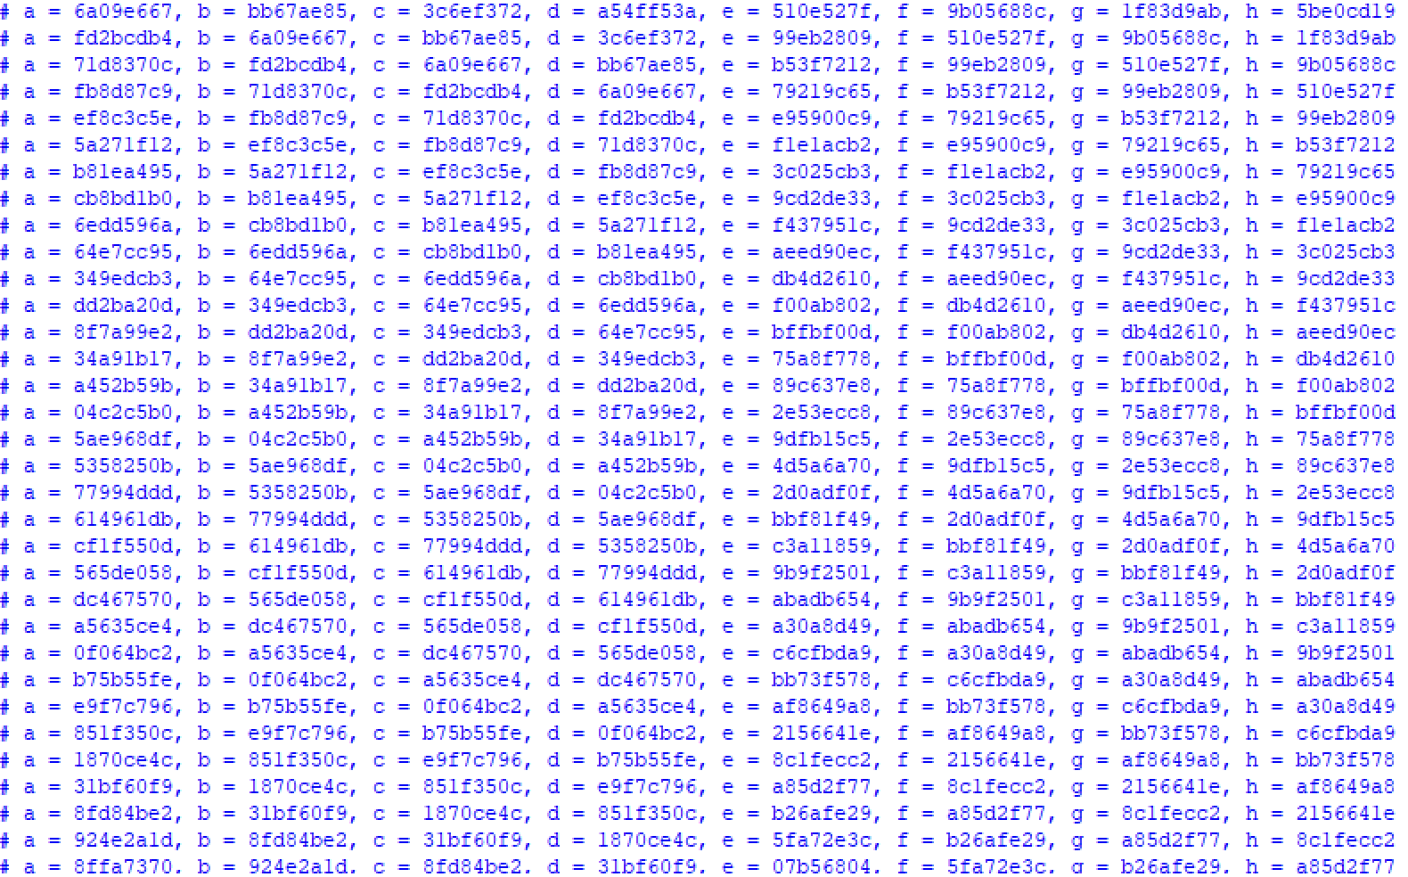

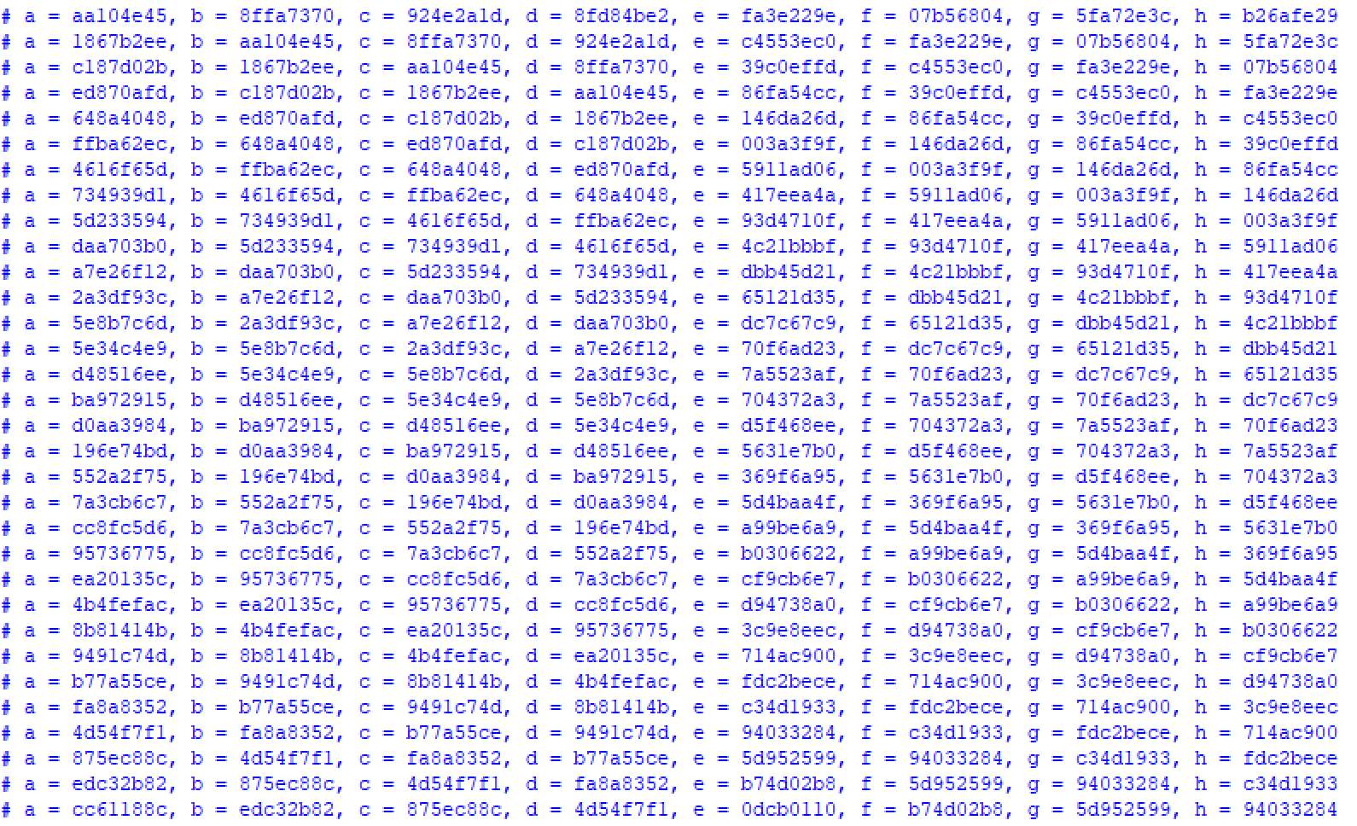

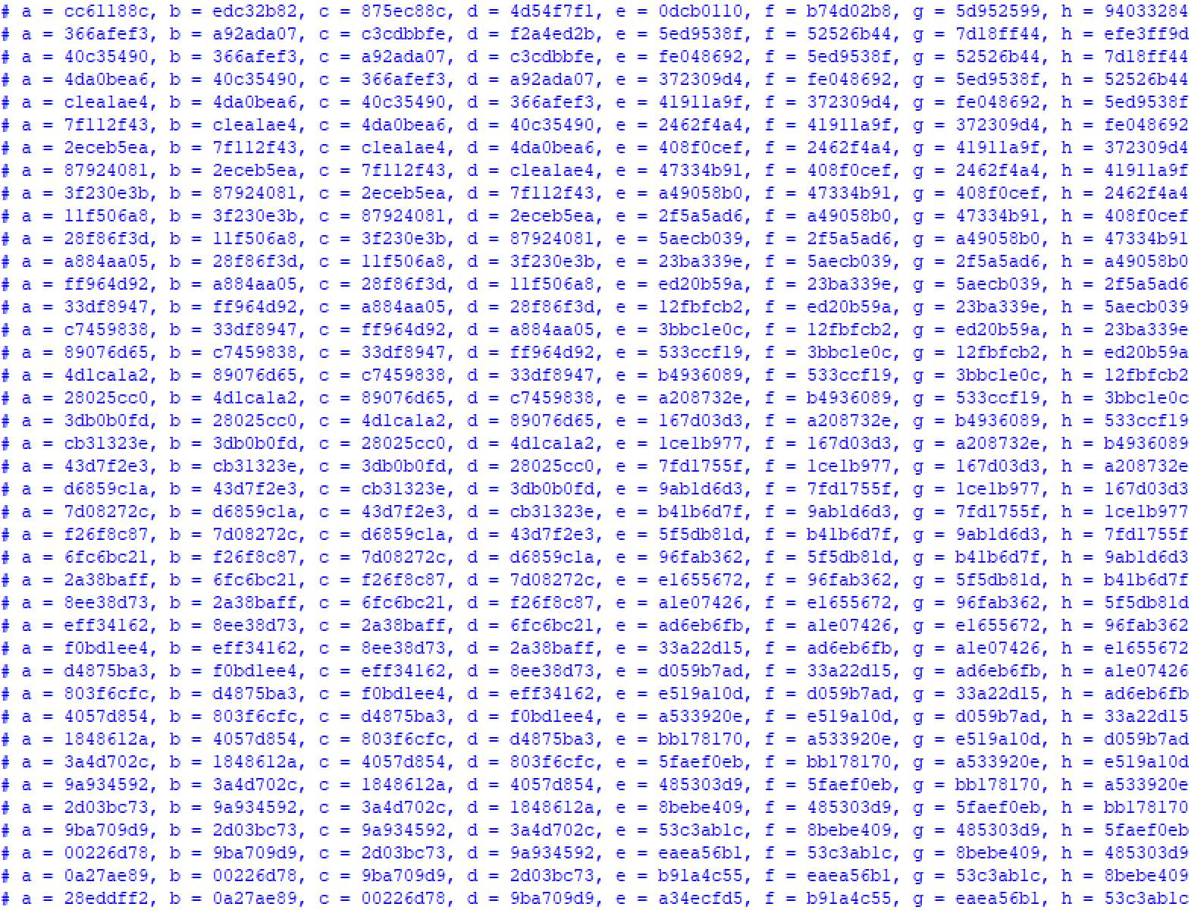

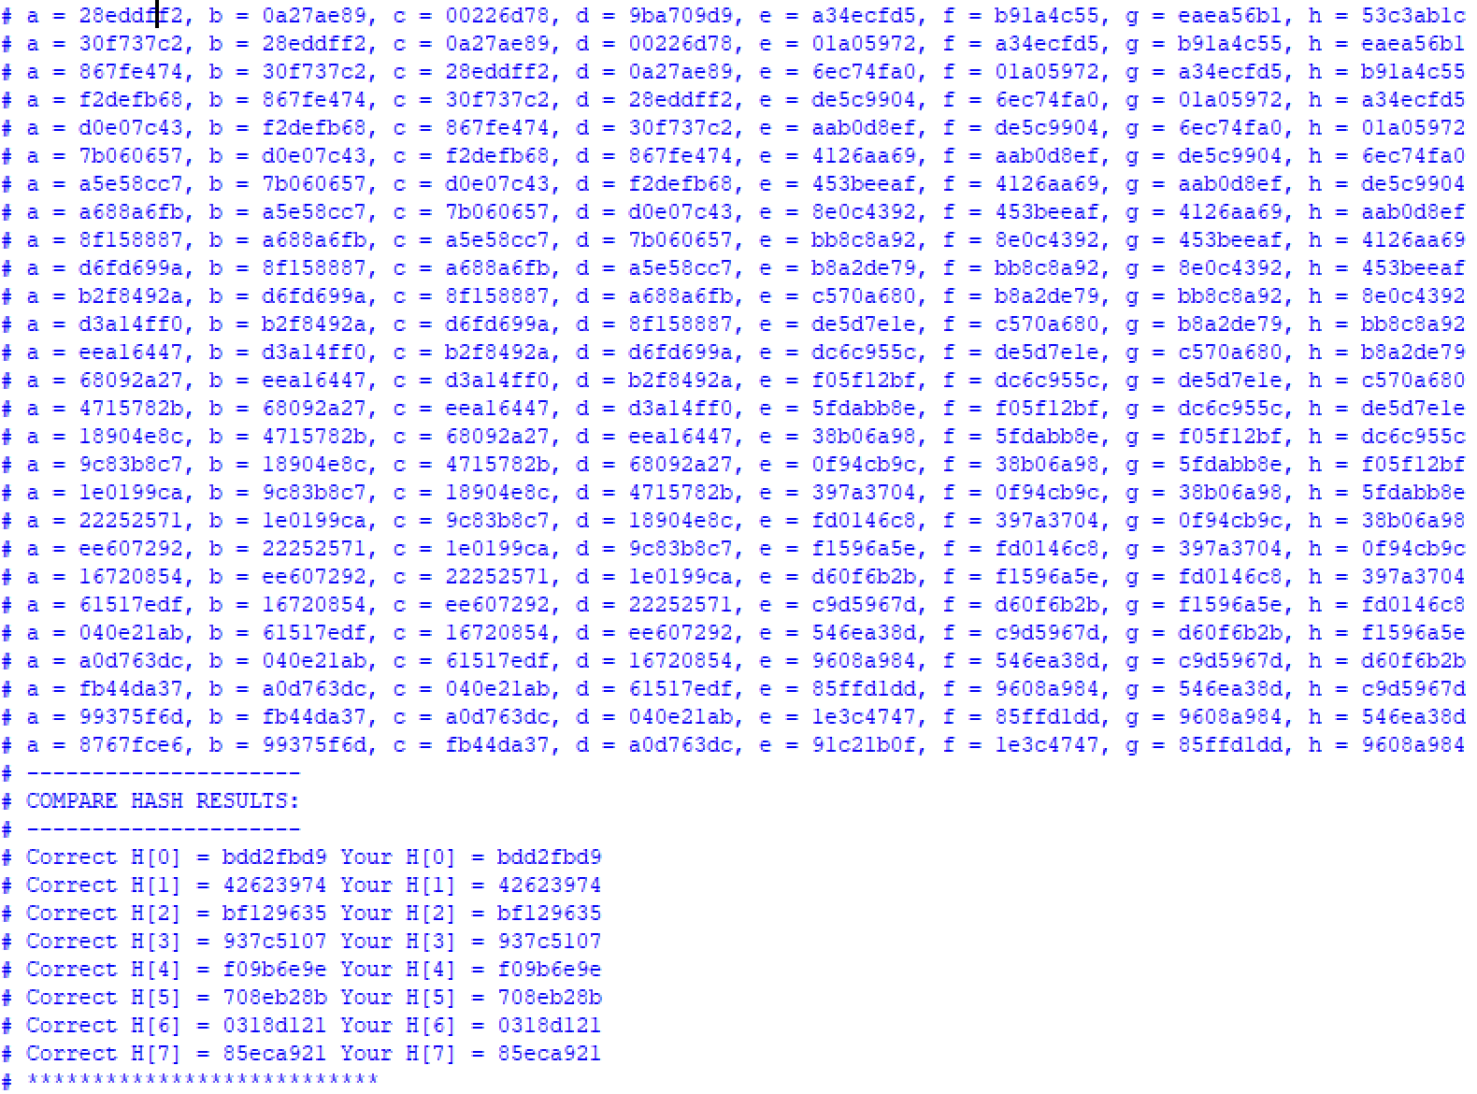

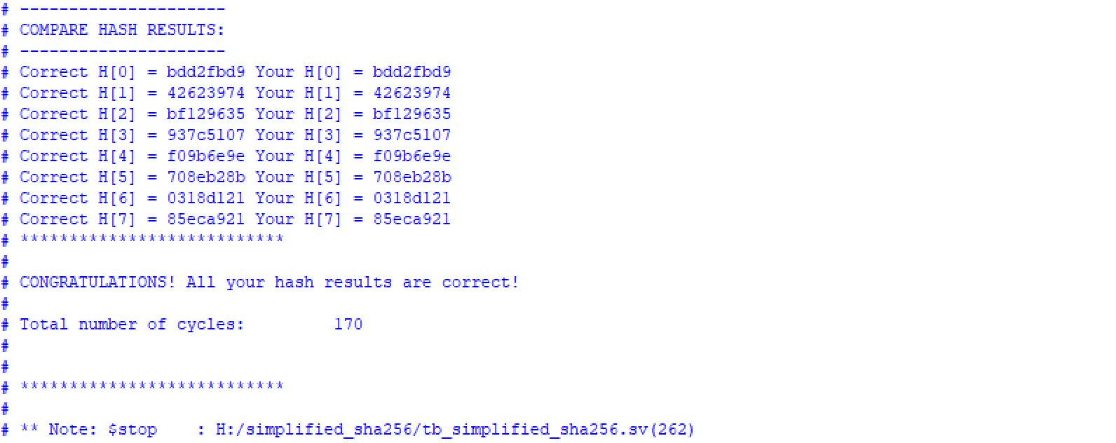

*Bitcoin Hashing:*

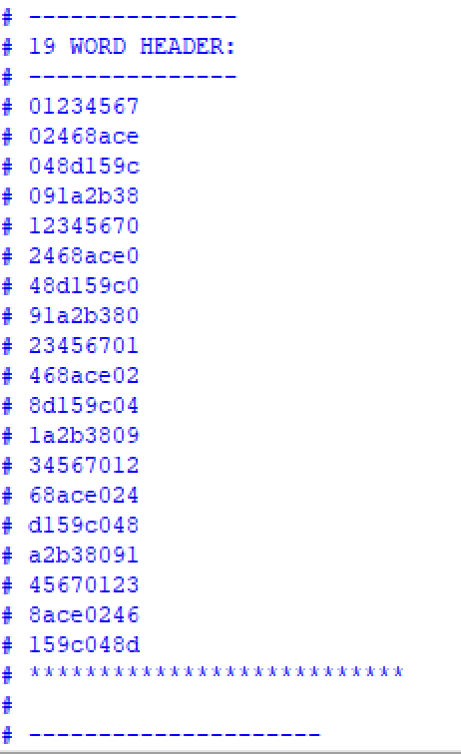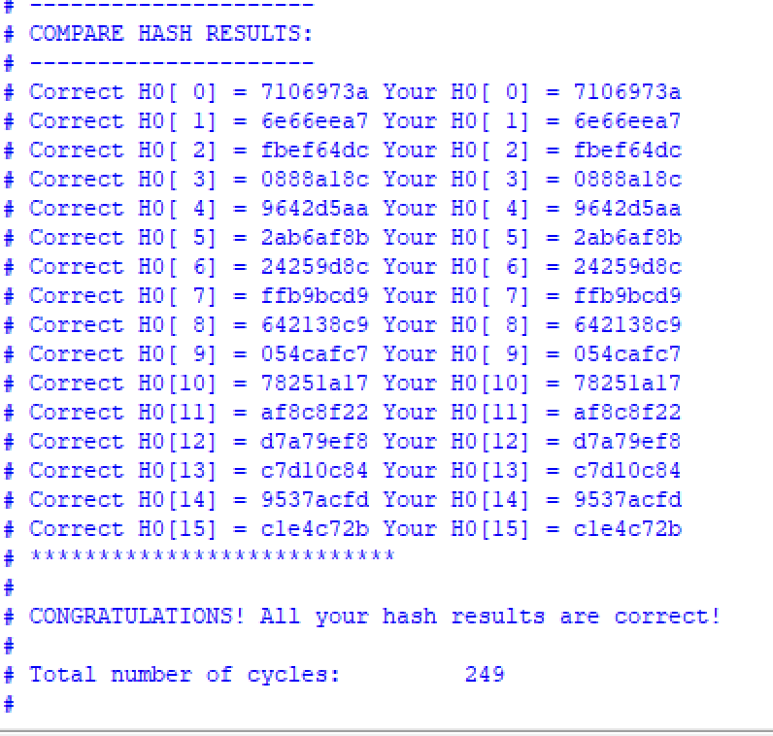

1. **Bitcoin Hash Resource Synthesis Snapshots**

*Resource Usage Snapshot:*

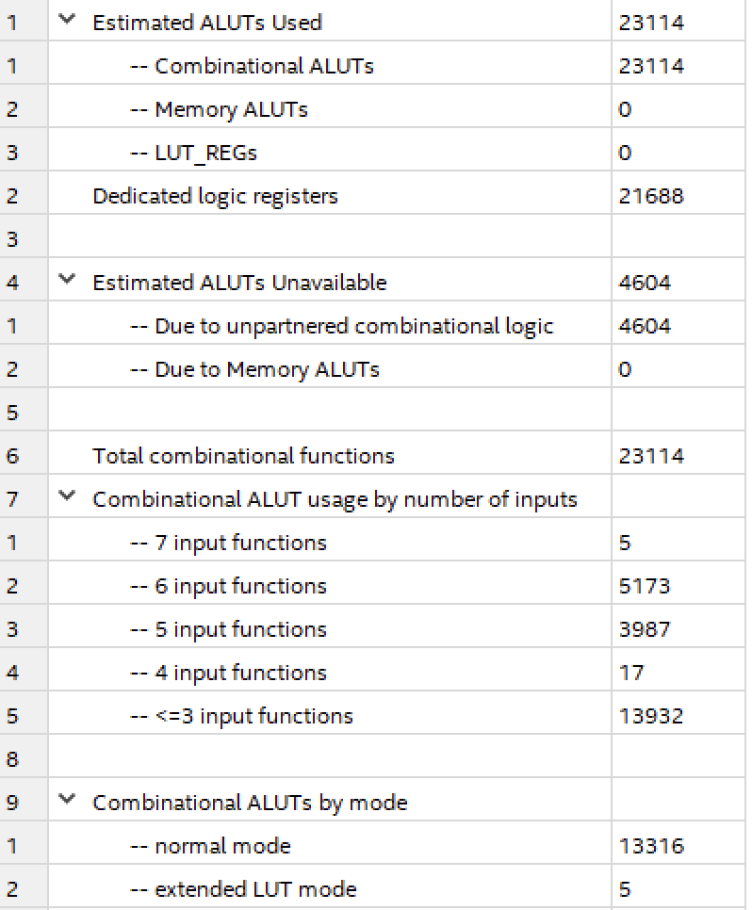

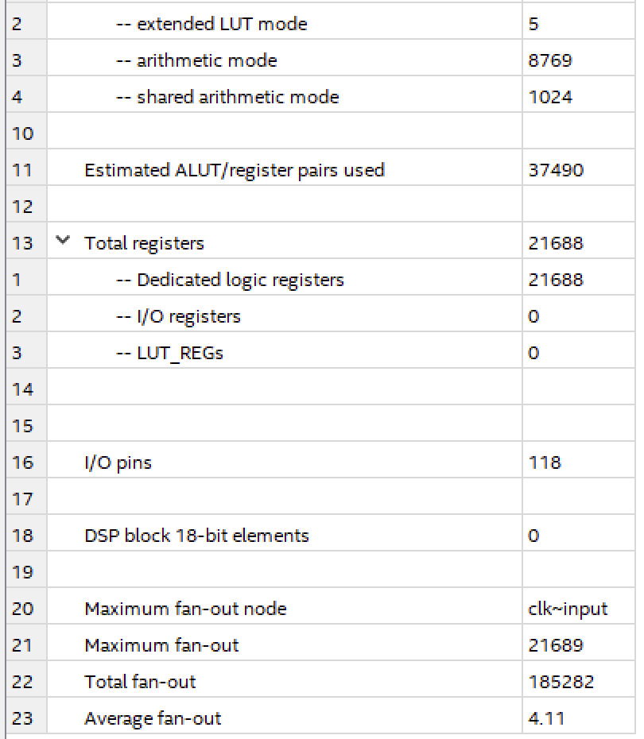

*Fitter Report Snapshot:*

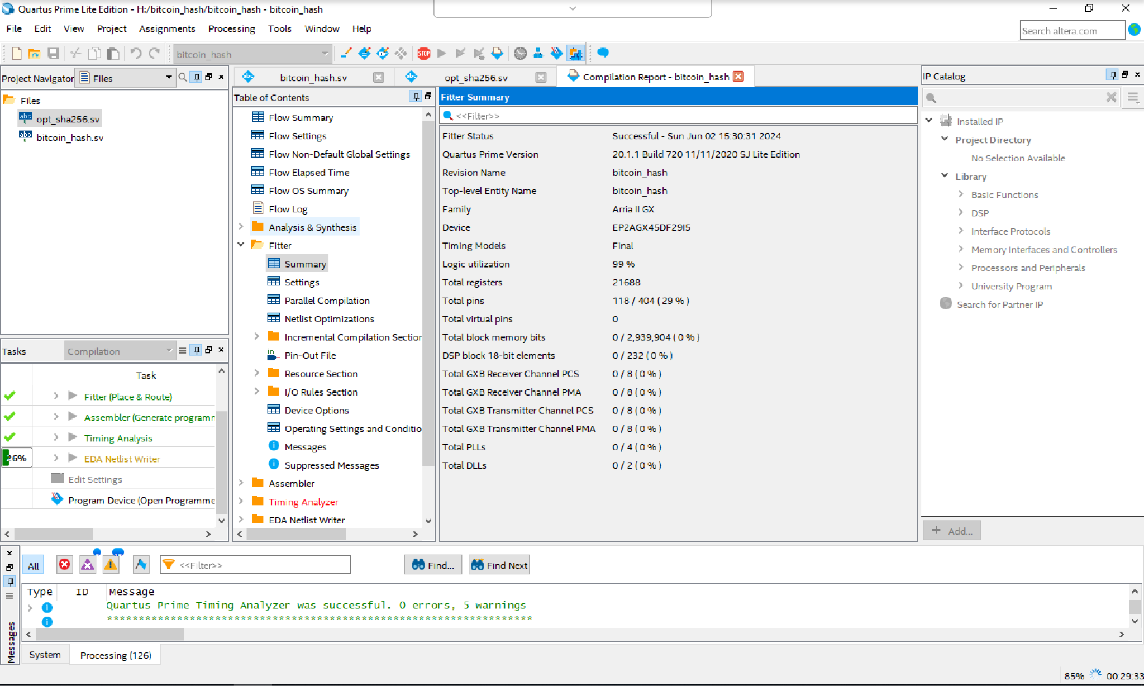

*Timing Report (Fmax) Snapshot:*

